11.Create a java script enabaled webpage that performs basic arithmetic operation using input from users..

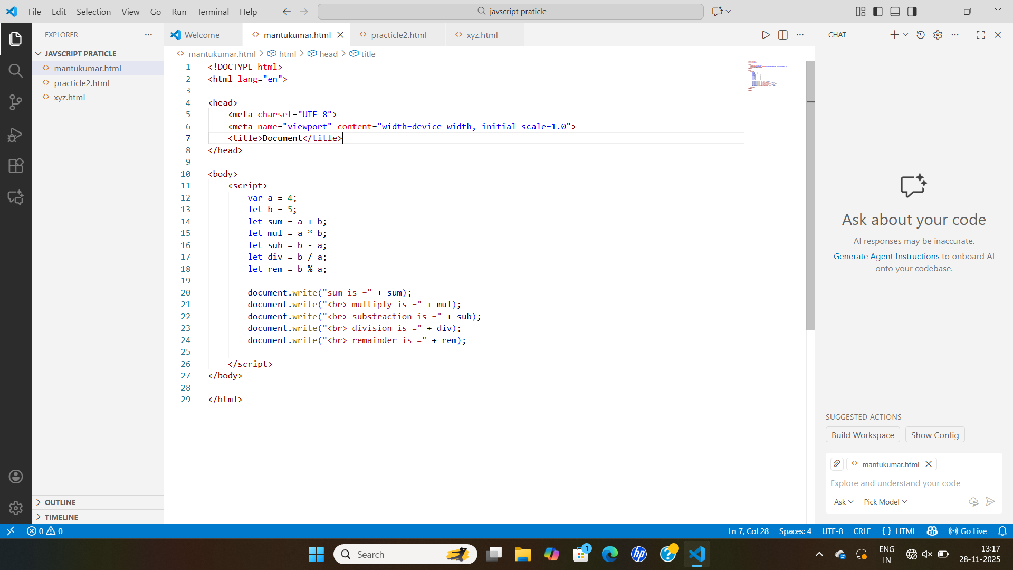

Output-
